Nested Additive Solids

Definition
# Source: AI Source: Provided by: [Data Path: Persons Table -> ID Column: 1, Name_En Column: Motasem Essam] -> From: [ChatGPT] on [7/25/2026]
Nested Additive Solids are composite three-dimensional objects formed by placing two or more solid components inside, around, or partially within one another, while combining their volumes to create a larger composite structure.
Unlike ordinary nested solids, which may involve hollow spaces or material removal, nested additive solids involve the addition of solid components. Their arrangement may include components that are partially embedded, enclosed, or fitted together.
The components may have identical or different geometric shapes and dimensions.
Simple Definition: Nested additive solids are formed by adding solid shapes that are positioned inside, around, or partly within one another.

Geometric Representation
# Source: AI Source: Provided by: [Data Path: Persons Table -> ID Column: 1, Name_En Column: Motasem Essam] -> From: [ChatGPT] on [7/25/2026]
Nested additive arrangements may include:
- A smaller solid partially embedded inside a larger solid.
- A solid enclosed within another solid, with the component volumes overlapping.
- Multiple solid layers arranged around a central component.
- Different solid shapes fitted together to form one composite structure.
- Repeated solid components arranged within a larger solid framework.
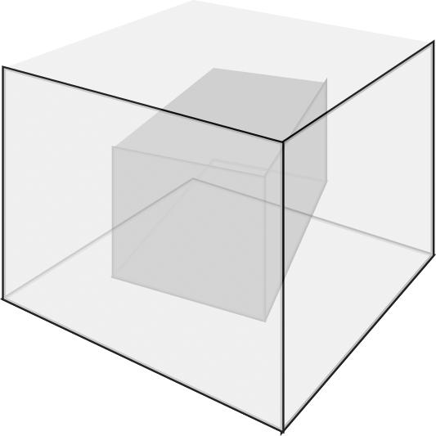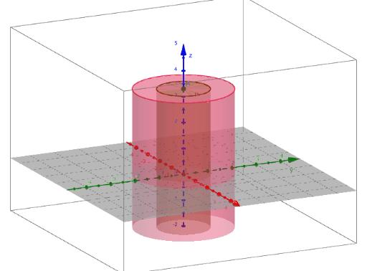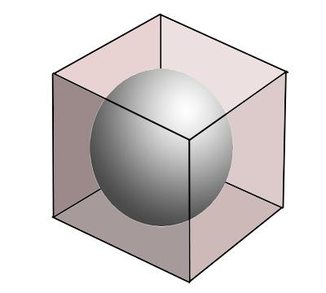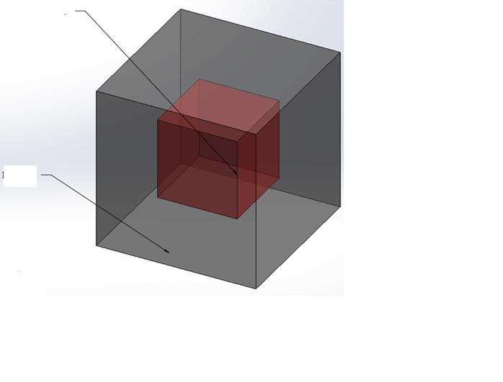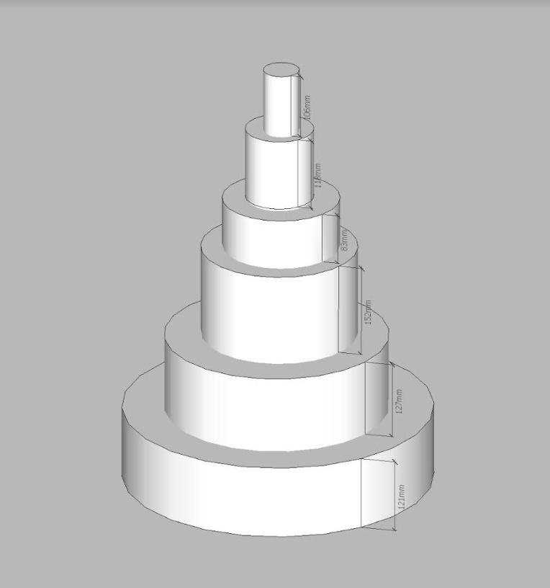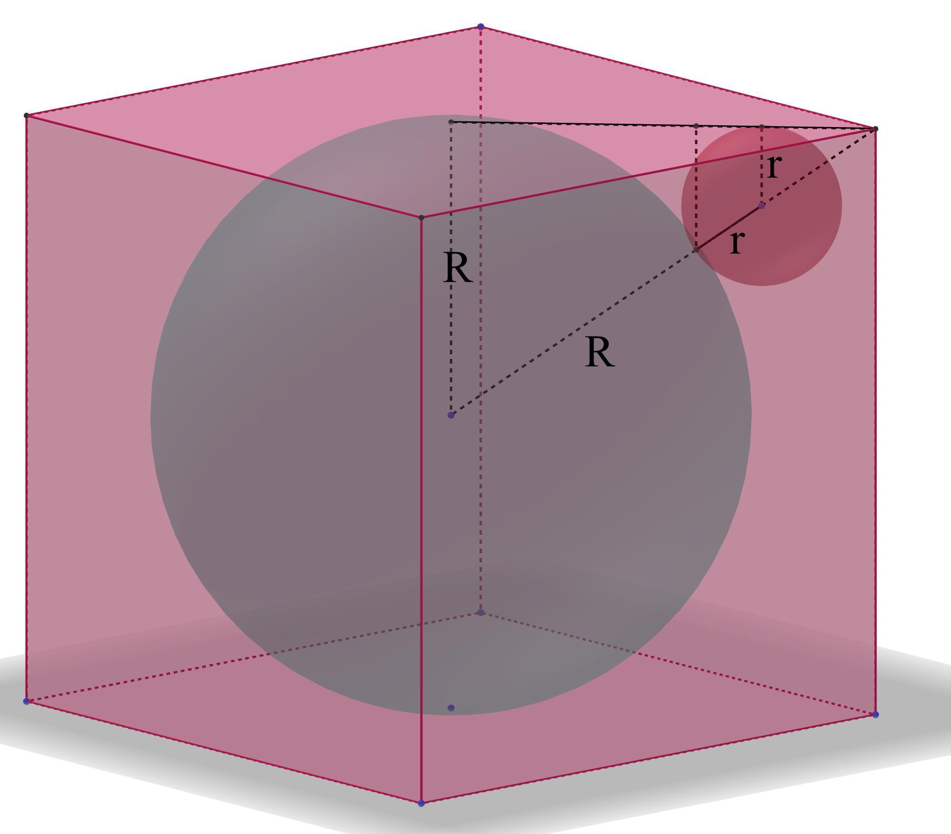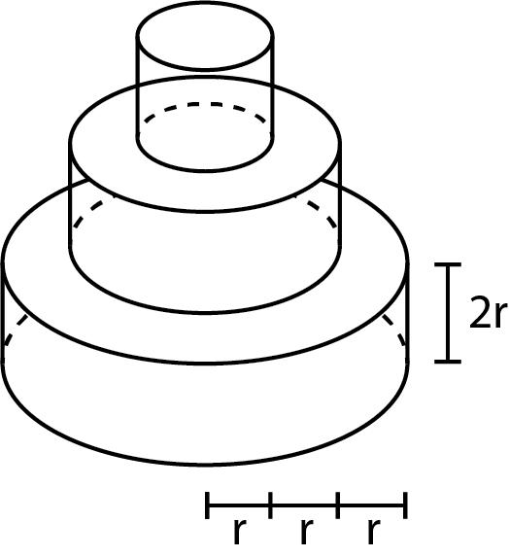

Main Classification

Types of Nested Additive Solids
# Source: AI Source: Provided by: [Data Path: Persons Table -> ID Column: 1, Name_En Column: Motasem Essam] -> From: [ChatGPT] on [7/25/2026]

Prism-Based Nested Additive Solids
# Source: AI Source: Provided by: [Data Path: Persons Table -> ID Column: 1, Name_En Column: Motasem Essam] -> From: [ChatGPT] on [7/25/2026]
Formed by arranging prism components inside or around other prism components.
Examples:
- A smaller rectangular prism partially embedded in a larger rectangular prism.
- Nested rectangular prisms with different dimensions.
- Polygonal prisms arranged around a central prism.
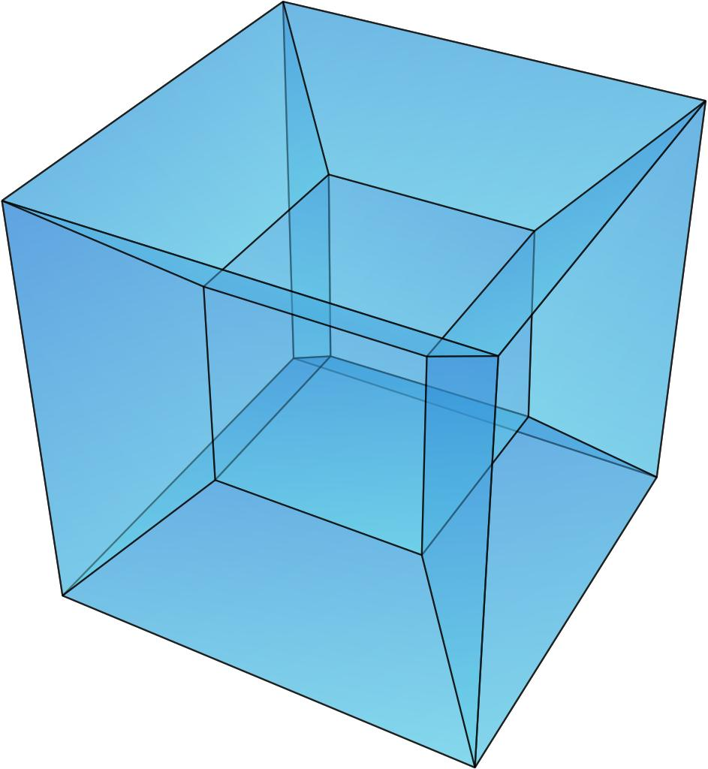

Cylinder-Based Nested Additive Solids
# Source: AI Source: Provided by: [Data Path: Persons Table -> ID Column: 1, Name_En Column: Motasem Essam] -> From: [ChatGPT] on [7/25/2026]
Formed by arranging cylindrical components inside or around other cylindrical components.
Examples:
- Coaxial cylinders with different radii and overlapping lengths.
- A smaller solid cylinder partially embedded in a larger cylinder.
- Multiple cylindrical components arranged concentrically.
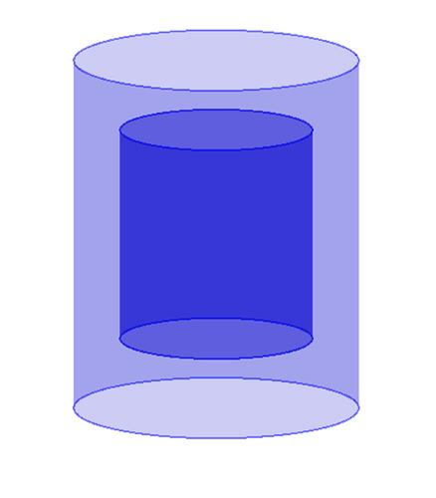

Cone-Based Nested Additive Solids
# Source: AI Source: Provided by: [Data Path: Persons Table -> ID Column: 1, Name_En Column: Motasem Essam] -> From: [ChatGPT] on [7/25/2026]
Formed by arranging conical components inside or around other conical components.
Examples:
- A smaller cone positioned inside a larger cone.
- Coaxial cones with partially overlapping regions.
- Multiple conical components arranged around a common center.
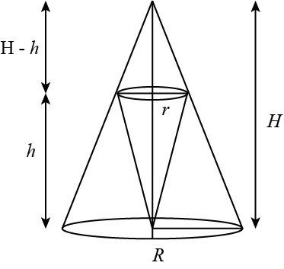

Pyramid-Based Nested Additive Solids
# Source: AI Source: Provided by: [Data Path: Persons Table -> ID Column: 1, Name_En Column: Motasem Essam] -> From: [ChatGPT] on [7/25/2026]
Formed by placing pyramidal components inside or around other pyramidal components.
Examples:
- A smaller square pyramid positioned inside a larger square pyramid.
- Nested pyramids sharing a common vertical axis.
- Multiple pyramids arranged around a central pyramid.
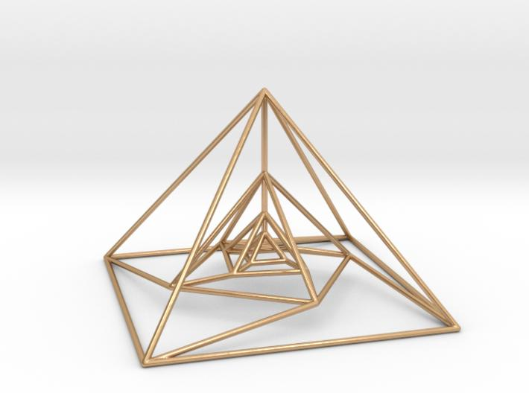

Sphere-Based Nested Additive Solids
# Source: AI Source: Provided by: [Data Path: Persons Table -> ID Column: 1, Name_En Column: Motasem Essam] -> From: [ChatGPT] on [7/25/2026]
Formed by arranging spherical components inside or around other spherical components.
Examples:
- Two solid spheres with different radii and a common center.
- A smaller sphere partially embedded in a larger sphere.
- Multiple spheres arranged concentrically.
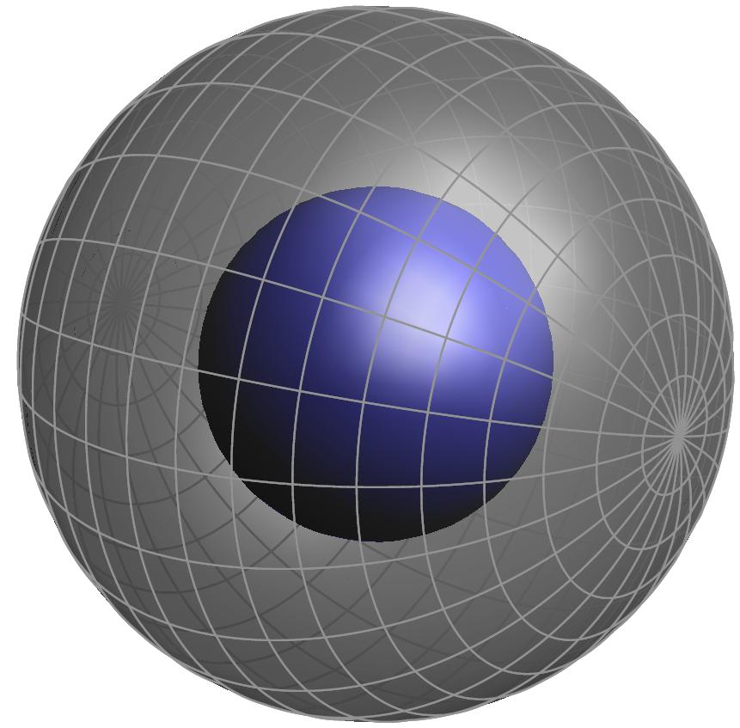

Hemisphere-Based Nested Additive Solids
# Source: AI Source: Provided by: [Data Path: Persons Table -> ID Column: 1, Name_En Column: Motasem Essam] -> From: [ChatGPT] on [7/25/2026]
Formed by placing hemispherical components inside or around other hemispherical components.
Examples:
- A smaller hemisphere positioned inside a larger hemisphere.
- Nested hemispheres sharing a common axis.
- Multiple hemispherical components arranged concentrically.
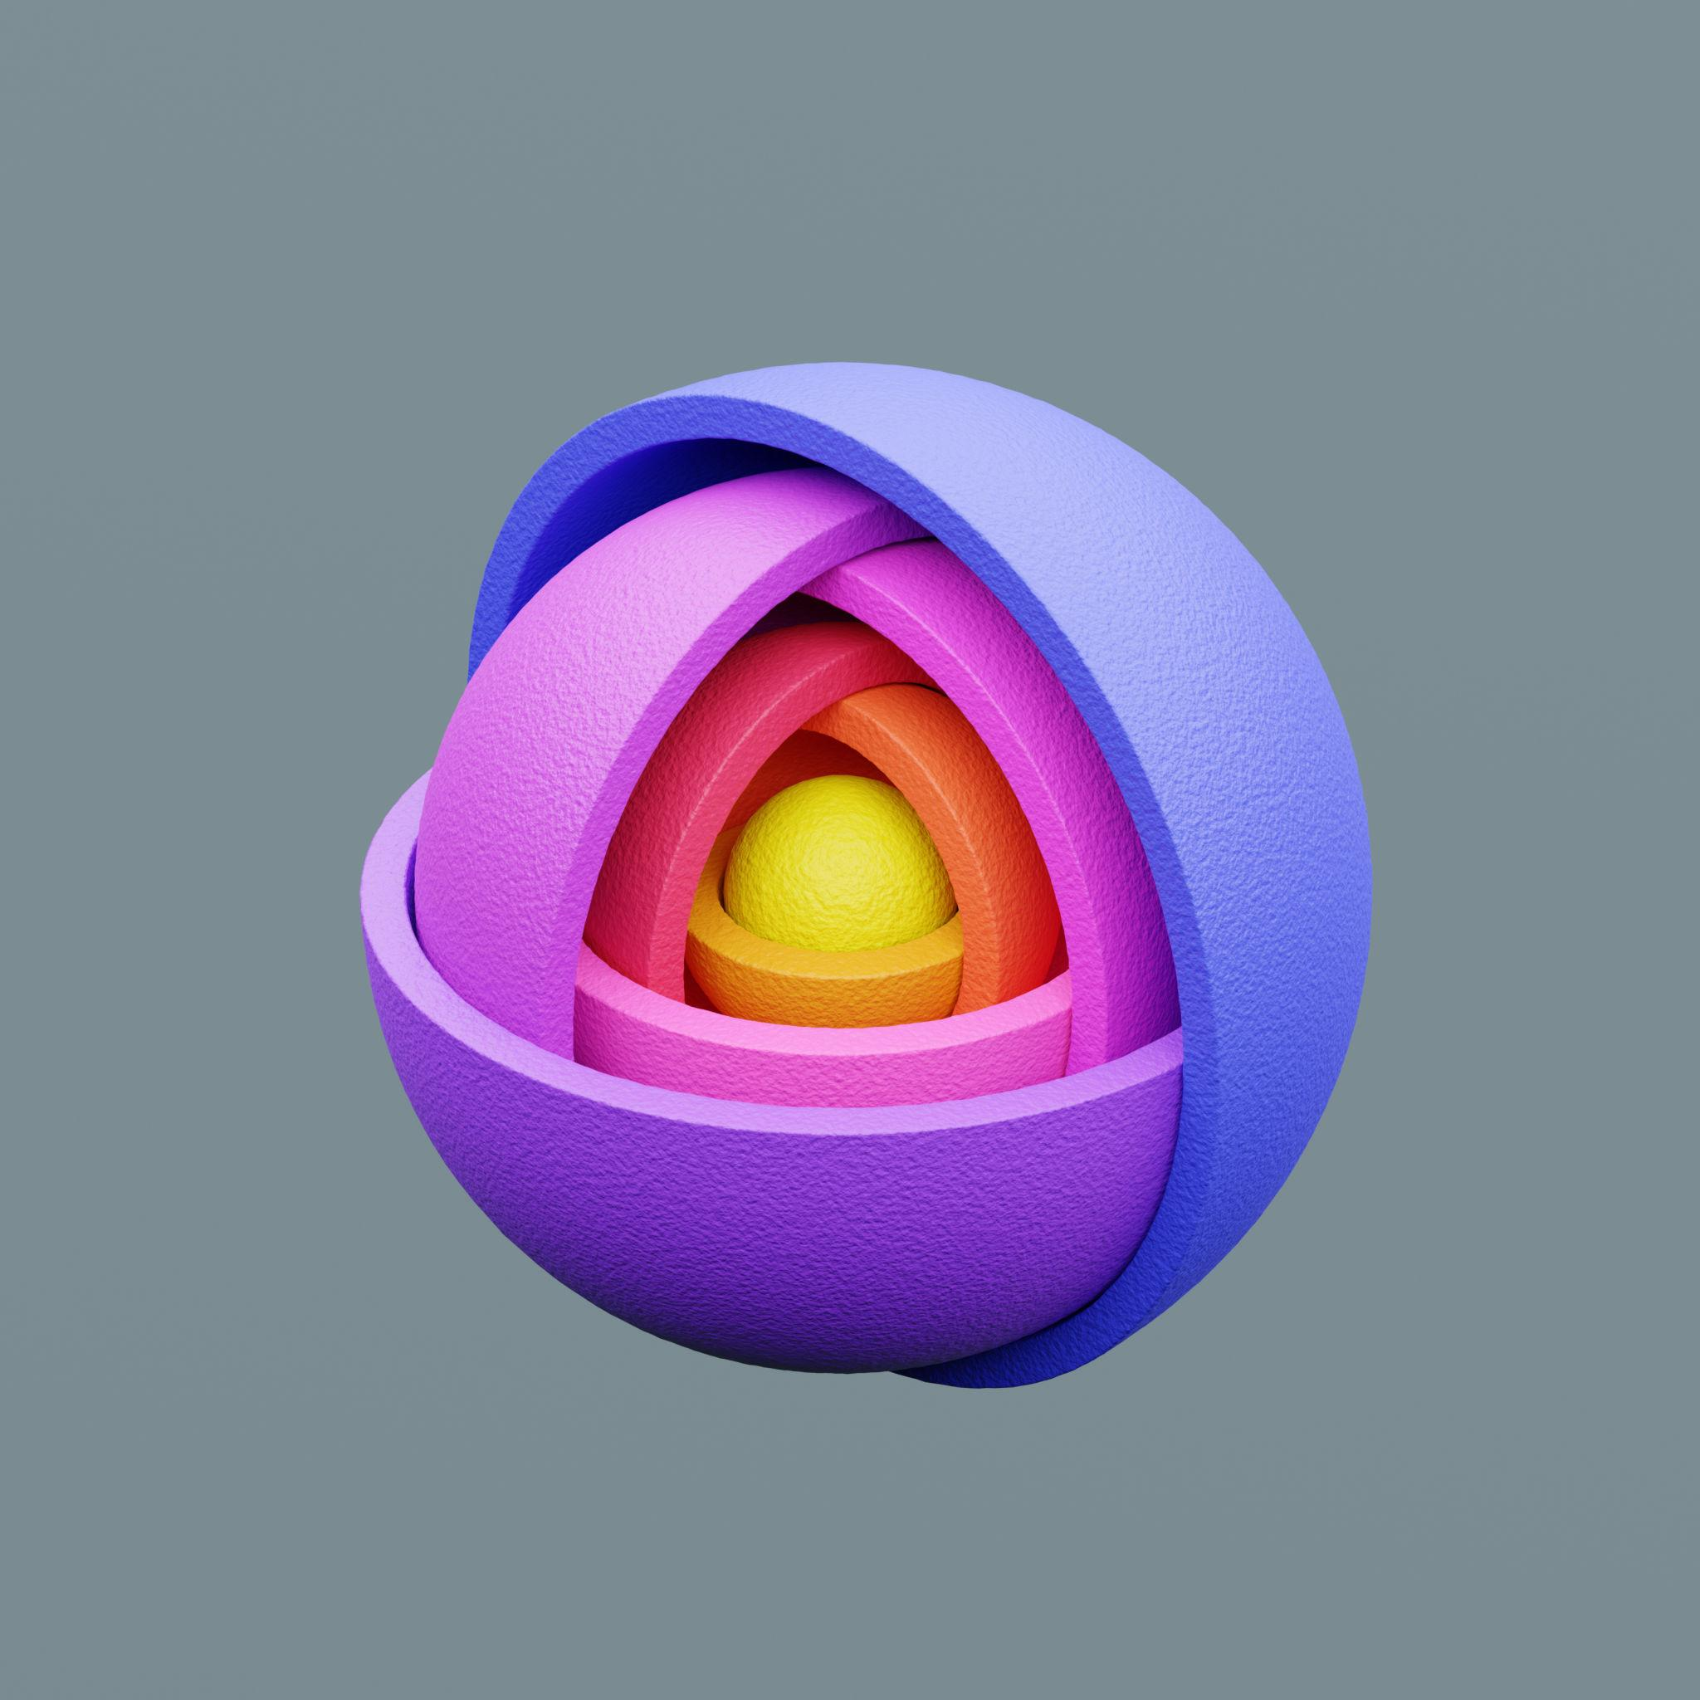

Mixed-Shape Nested Additive Solids
# Source: AI Source: Provided by: [Data Path: Persons Table -> ID Column: 1, Name_En Column: Motasem Essam] -> From: [ChatGPT] on [7/25/2026]
Formed by arranging different types of solid components inside or around one another.
Examples:
- A sphere partially embedded in a cube.
- A cylinder positioned inside a rectangular prism.
- A cone placed inside a cylindrical solid.
- A hemisphere combined with a prism and cylinder.
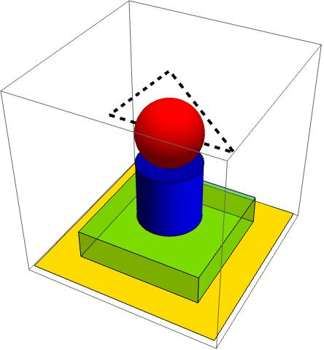

Classification by Nested Arrangement
# Source: AI Source: Provided by: [Data Path: Persons Table -> ID Column: 1, Name_En Column: Motasem Essam] -> From: [ChatGPT] on [7/25/2026]
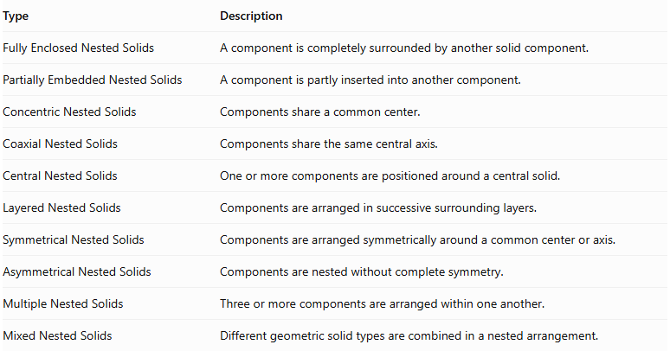
Type | Description
Fully Enclosed Nested Solids | A component is completely surrounded by another solid component.
Partially Embedded Nested Solids | A component is partly inserted into another component.
Concentric Nested Solids | Components share a common center.
Coaxial Nested Solids | Components share the same central axis.
Central Nested Solids | One or more components are positioned around a central solid.
Layered Nested Solids | Components are arranged in successive surrounding layers.
Symmetrical Nested Solids | Components are arranged symmetrically around a common center or axis.
Asymmetrical Nested Solids | Components are nested without complete symmetry.
Multiple Nested Solids | Three or more components are arranged within one another.
Mixed Nested Solids | Different geometric solid types are combined in a nested arrangement.
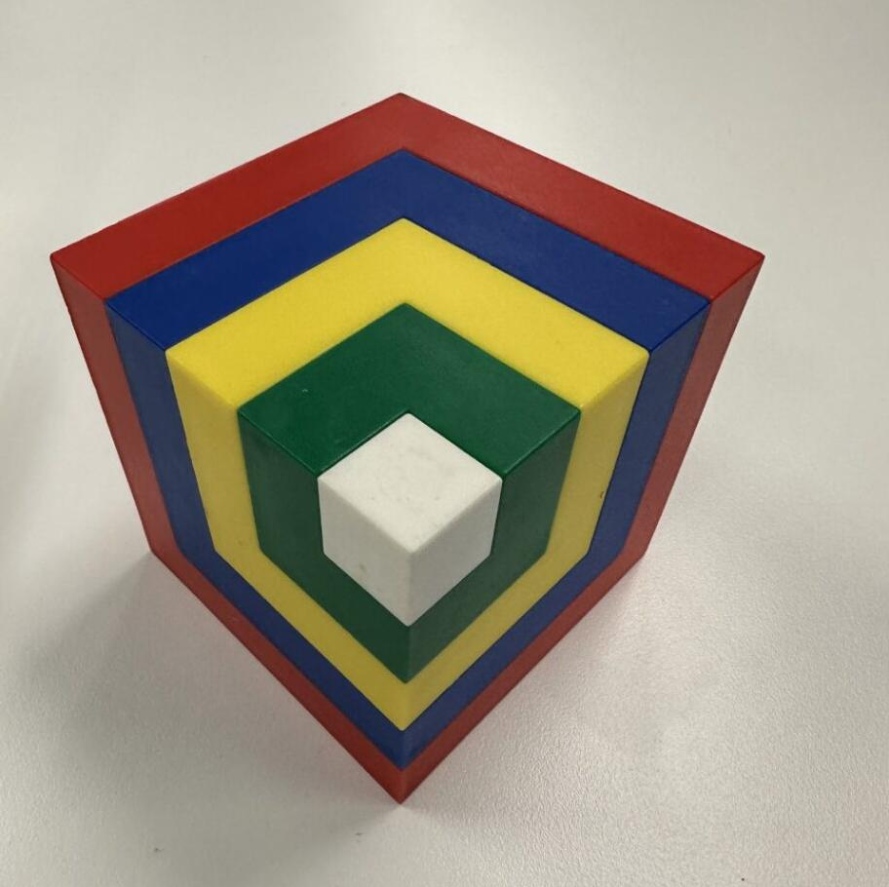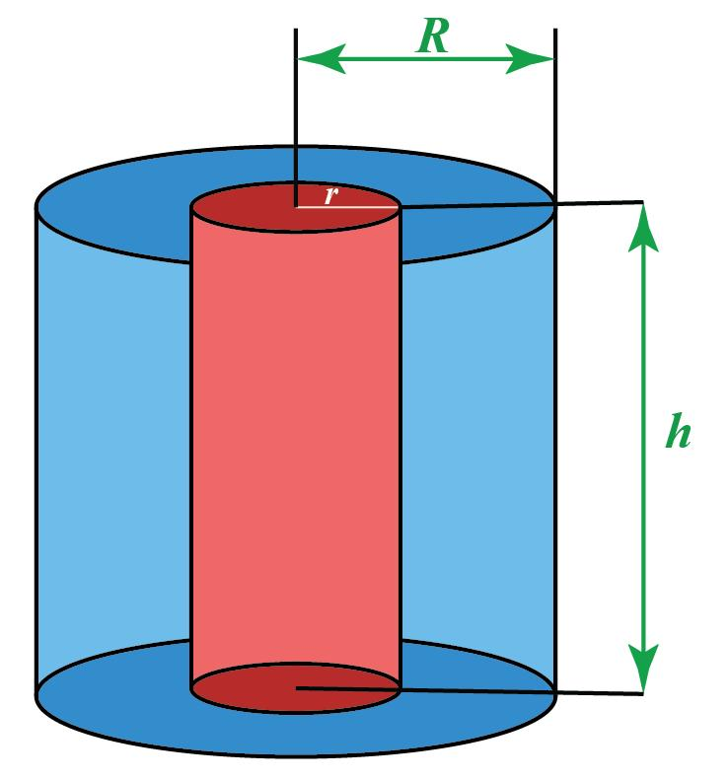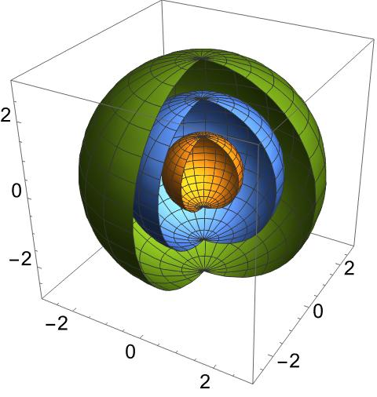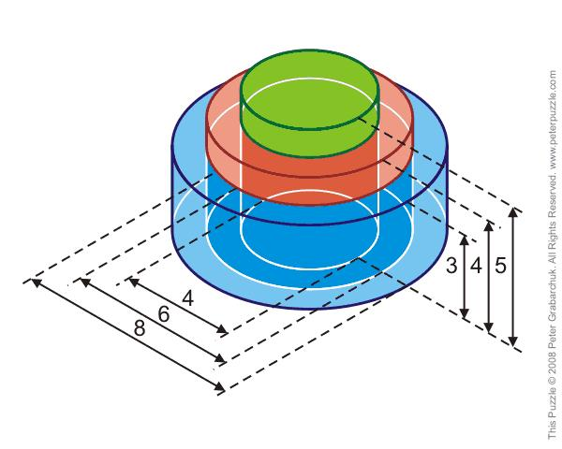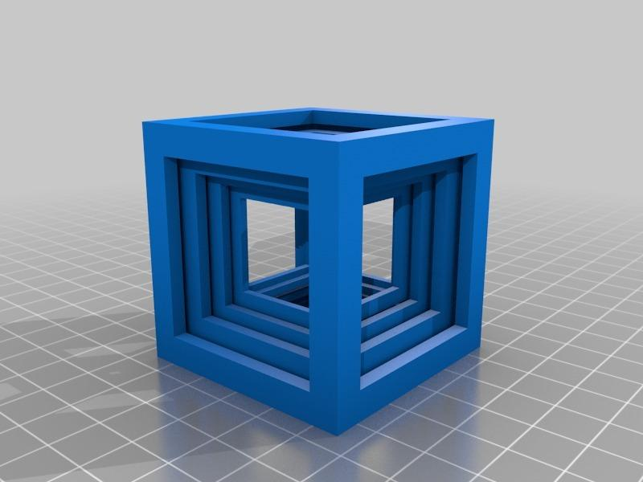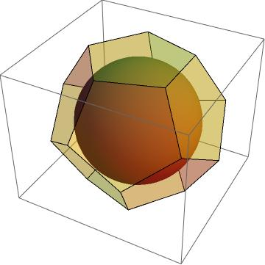

Classification by Component Position
# Source: AI Source: Provided by: [Data Path: Persons Table -> ID Column: 1, Name_En Column: Motasem Essam] -> From: [ChatGPT] on [7/25/2026]
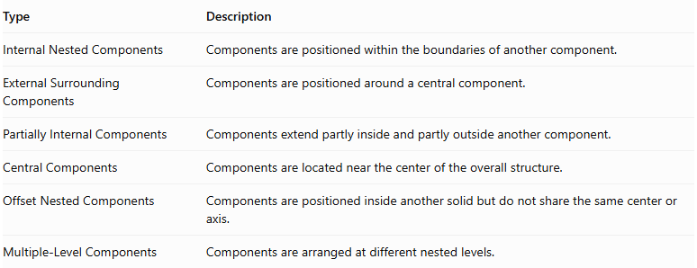
Type | Description
Internal Nested Components | Components are positioned within the boundaries of another component.
External Surrounding Components | Components are positioned around a central component.
Partially Internal Components | Components extend partly inside and partly outside another component.
Central Components | Components are located near the center of the overall structure.
Offset Nested Components | Components are positioned inside another solid but do not share the same center or axis.
Multiple-Level Components | Components are arranged at different nested levels.

Classification by Component Relationship
# Source: AI Source: Provided by: [Data Path: Persons Table -> ID Column: 1, Name_En Column: Motasem Essam] -> From: [ChatGPT] on [7/25/2026]
- Equal-Shape Nested Solids: Components have identical geometric shapes.
- Different-Size Nested Solids: Components have the same shape but different dimensions.
- Mixed-Shape Nested Solids: Components have different geometric shapes.
- Repeated Nested Solids: Several identical components are arranged within a larger solid.
- Concentric Nested Solids: Components share a common center.
- Coaxial Nested Solids: Components share a common axis.

Mathematical Properties and Formulas
# Source: AI Source: Provided by: [Data Path: Persons Table -> ID Column: 1, Name_En Column: Motasem Essam] -> From: [ChatGPT] on [7/25/2026]
The mathematical properties depend on the degree of overlap, the component positions, and the amount of material shared between components.

Volume
# Source: AI Source: Provided by: [Data Path: Persons Table -> ID Column: 1, Name_En Column: Motasem Essam] -> From: [ChatGPT] on [7/25/2026]
For nested additive solids, simply adding all component volumes may double-count regions where their interiors overlap.
For two components:
$$V_{total}=V_{1}+V_{2}-V_{overlap}$$
Where:
- $V_{1}$ = Volume of the first component.
- $V_{2}$ = Volume of the second component.
- $V_{overlap}$ = Volume of the region occupied by both components.
For multiple components, the overlap corrections must account for all shared regions without double-counting.
Important distinction:
- If components are nested without overlapping interiors, their volumes can be added.
- If components overlap, the overlapping volume must be counted only once.
- If one solid is completely inside another, the combined physical volume is the volume of the larger solid, assuming both occupy the same material region.

External Surface Area
# Source: AI Source: Provided by: [Data Path: Persons Table -> ID Column: 1, Name_En Column: Motasem Essam] -> From: [ChatGPT] on [7/25/2026]
The external surface area includes only surfaces exposed to the outside of the complete composite structure.
For overlapping or embedded components:
- Hidden surfaces are excluded.
- Exposed portions of each component remain included.
- Internal contact surfaces are not counted as external surfaces.
- The actual exposed surface must be determined from the geometry of the union.
Therefore, the simple formula of adding individual surface areas is generally not valid for nested additive solids.

Volume of Common Nested Shapes
# Source: AI Source: Provided by: [Data Path: Persons Table -> ID Column: 1, Name_En Column: Motasem Essam] -> From: [ChatGPT] on [7/25/2026]
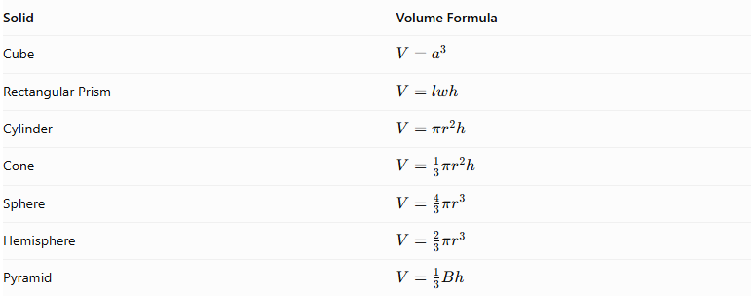
Solid | Volume Formula
Cube | $$V=a^{3}$$
Rectangular Prism | $$V=lwh$$
Cylinder | $$V=πr^{2}h$$
Cone | $$V=\frac{1}{3}πr^{2}h$$
Sphere | $$V=\frac{4}{3}πr^{3}$$
Hemisphere | $$V=\frac{2}{3}πr^{3}$$
Pyramid | $$V=\frac{1}{3}Bh$$

Worked Examples

Example 1: Two Concentric Solid Spheres
# Source: AI Source: Provided by: [Data Path: Persons Table -> ID Column: 1, Name_En Column: Motasem Essam] -> From: [ChatGPT] on [7/25/2026]
A smaller solid sphere is completely enclosed within a larger solid sphere. Both spheres share the same center.
- Radius of the larger sphere: $R=5$ cm
- Radius of the smaller sphere: $r=3$ cm
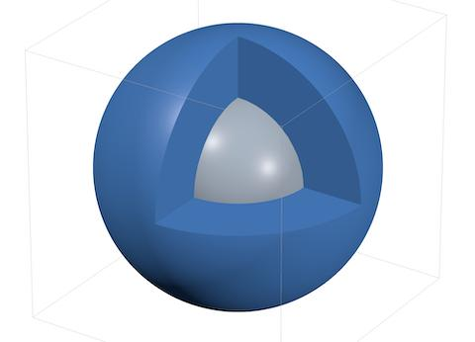
Step 1: Calculate the volume of the larger sphere.
$$V_{1}=\frac{4}{3}πR^{3}$$
$$V_{1}=\frac{4}{3}π(5)^{3}$$
$$V_{1}=\frac{500}{3}π$$
Step 2: Calculate the volume of the smaller sphere.
$$V_{2}=\frac{4}{3}πr^{3}$$
$$V_{2}=\frac{4}{3}π(3)^{3}$$
$$V_{2}=36π$$
Step 3: Determine the total occupied volume.
Because the smaller sphere is completely inside the larger sphere, its entire volume overlaps with the larger sphere.
$$V_{overlap}=36π$$
$$V_{total}=V_{1}+V_{2}-V_{overlap}$$
$$V_{total}=\frac{500}{3}π+36π-36π$$
$$\boxed{V_{total}=\frac{500}{3}π≈523.60{ cm}^{3}}$$
Step 4: Determine the external surface area.
Only the outer sphere is exposed.
$$SA=4πR^{2}$$
$$SA=4π(5)^{2}$$
$$\boxed{SA=100π≈314.16{ cm}^{2}}$$

Example 2: A Sphere Partially Embedded in a Cube
# Source: AI Source: Provided by: [Data Path: Persons Table -> ID Column: 1, Name_En Column: Motasem Essam] -> From: [ChatGPT] on [7/25/2026]
A solid sphere is partially embedded in a cube. The sphere intersects the cube, and part of its surface remains exposed outside the cube.
- Cube side length: $a=8$ cm
- Sphere radius: $r=3$ cm
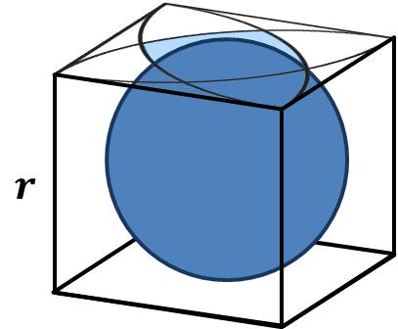
Step 1: Calculate the volume of the cube.
$$V_{c}=a^{3}$$
$$V_{c}=8^{3}=512{ cm}^{3}$$
Step 2: Calculate the volume of the sphere.
$$V_{s}=\frac{4}{3}πr^{3}$$
$$V_{s}=\frac{4}{3}π(3)^{3}$$
$$V_{s}=36π≈113.10{ cm}^{3}$$
Step 3: Determine the total volume.
The sphere's center position and the depth of its intersection with the cube are needed to calculate the overlapping volume.
The general formula is:
$$V_{total}=512+36π-V_{overlap}$$
Step 4: Determine the external surface area.
The external surface area consists of:
- The exposed cube surfaces.
- The exposed portion of the sphere's curved surface.
The exact result requires the sphere's position relative to the cube and the geometry of their intersection.
Important: The sphere's complete surface area must not be added to the cube's complete surface area because part of the sphere and part of the cube are hidden within the combined structure.

Important Characteristics
# Source: AI Source: Provided by: [Data Path: Persons Table -> ID Column: 1, Name_En Column: Motasem Essam] -> From: [ChatGPT] on [7/25/2026]
- They consist of two or more solid components arranged within or around one another.
- Components may have identical or different geometric shapes.
- Components may be fully enclosed, partially embedded, or arranged in surrounding layers.
- Their centers or axes may coincide or be offset.
- Their component interiors may overlap.
- Overlapping volumes must be counted only once.
- Hidden surfaces are excluded from the external surface area.
- They may contain repeated or mixed-shape components.
- Their overall geometry depends on the relative positions and dimensions of the components.

Comparison with Other Composite Solid Arrangements
# Source: AI Source: Provided by: [Data Path: Persons Table -> ID Column: 1, Name_En Column: Motasem Essam] -> From: [ChatGPT] on [7/25/2026]
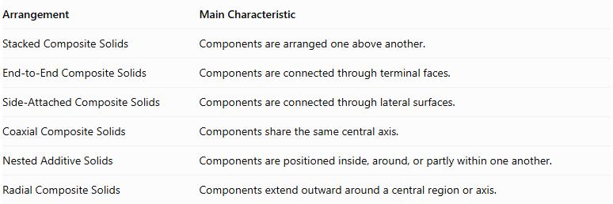
Arrangement | Main Characteristic
Stacked Composite Solids | Components are arranged one above another.
End-to-End Composite Solids | Components are connected through terminal faces.
Side-Attached Composite Solids | Components are connected through lateral surfaces.
Coaxial Composite Solids | Components share the same central axis.
Nested Additive Solids | Components are positioned inside, around, or partly within one another.
Radial Composite Solids | Components extend outward around a central region or axis.

Applications
# Source: AI Source: Provided by: [Data Path: Persons Table -> ID Column: 1, Name_En Column: Motasem Essam] -> From: [ChatGPT] on [7/25/2026]
Nested additive solids can represent:
- Mechanical assemblies with embedded components.
- Composite construction structures.
- Layered architectural components.
- Embedded spherical or cylindrical structures.
- Multi-layer solid models.
- Industrial components with internal solid inserts.
- Three-dimensional geometric modeling and CAD assemblies.

Key Points
# Source: AI Source: Provided by: [Data Path: Persons Table -> ID Column: 1, Name_En Column: Motasem Essam] -> From: [ChatGPT] on [7/25/2026]
- Nested additive solids are formed by arranging multiple solid components inside, around, or partly within one another.
- They can contain prisms, cylinders, cones, pyramids, spheres, hemispheres, or mixed shapes.
- Their arrangements may be concentric, coaxial, layered, fully enclosed, or partially embedded.
- Their volume must account for overlapping regions.
- Their external surface area includes only exposed surfaces.
- Component positions and intersection geometry are essential for accurate calculations.

Conclusion
# Source: AI Source: Provided by: [Data Path: Persons Table -> ID Column: 1, Name_En Column: Motasem Essam] -> From: [ChatGPT] on [7/25/2026]
Nested Additive Solids are composite three-dimensional structures formed by combining solid components arranged inside, around, or partly within one another. Their defining feature is the nested spatial relationship between their components. They can contain identical or mixed geometric shapes and may involve fully enclosed, partially embedded, concentric, or layered arrangements. Accurate calculations require accounting for overlapping volumes and identifying only the surfaces exposed to the outside.

